41.17: 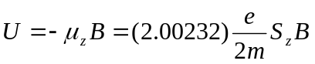
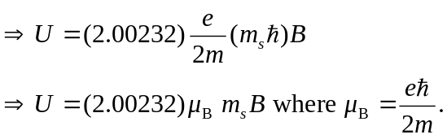
So the energy difference
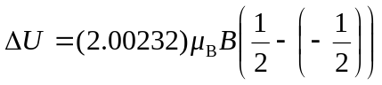
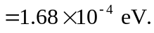
And the lower energy level is 